A Model for Finding Flight Optimal Overbooking Levels based on Binomial Distribution

Shengyu Chen, Kaiye Yang, and Zhimin Wu

Contents

Introduction 2

Assumptions 3

Model Building 4

Solving the Equation 6

Case Analysis 7

References 9

# Introduction

Before the widespread pandemic, the airline worldwide continued to expand. Historically, the global aviation industry doubled in size every 15 years, developing faster than most other transport sections. Recorded by ATAG (2019), commercial flights universally carried over 4.3 billion passengers to their expected destinations, generating $704.4 billion of direct revenue from ticket sales and almost $1.3 trillion benefits from tourism catalytic products. Tremendous populations of international mobility have spurred the service improvements across the airways to satisfy the diversified needs of tourists (such as having more comfortable cabin space, one-day city tour, and discount tickets), in terms of developing diverse levels of cabin classes, feeder schemes, and on-demand pricing strategies (Dalalah et al, 2020). Although airlines have created a variety of service packages and corresponding terms for the massive travel market on the macro perspective, they are still concerned by the passenger boarding rate on the micro-level (like for a certain flight perspective). According to Belobaba’s research on boarding rate (2009), only 85%-90% of American tourists will successfully be on board in their domestic flights, while only 70% of customers can arrive at the cabin on time during the holiday peak. Several airlines implemented penalties for no-show passengers, most commercial airlines are reluctant to impose fines since those who have not shown up may be flying for business rather than leisure after having internal investigation (Schubmehl et al., 2002), while punishing them could deteriorate their long-term brand loyalty. In the absence of effective constraints on passenger’s attendance, if airlines invest more money on fleet expansion or cabin upgrade, they will lose more per seat even if the passenger’s no-show rate is maintained. Thus, most air companies have applied overbooking to compensate for the anticipated losses by passengers’ no-show, which allows them to accept reservations that exceed the seat capacity and compulsorily refuses to board travellers who haven’t been allocated enough seats (Rothstein, 1971). Overbooking mechanism seems reasonable to the airlines, but not for overbooked passengers who have no idea whether they are allowed to board until the last minutes since lacking information about the overbooking algorithms behind. For instance, United Express has randomly selected four overbooked passengers on a flight and asked them to leave to make rooms for flight attendants. If its proposal was rejected, passengers would be battered and forcibly dragged off their seats under the empowerment of airport police (Pizam, 2017). It is disastrous that the consequences of such imprecise overbooking algorithms on United Express: their story was retweeted 6.8 million times on the first day, followed by a 0.2% decrease in the stock price, and more than 23% of customers said they didn't want to travel with its flight forever (Stevens, 2017). Therefore, it is a long-term challenge for airlines on how to measure an accurate overbooking number for maximally their revenue but reducing the risks of forcing their passengers to leave the cabin.

In reference to previous research on this subject, several flight-related variables can be considered in our model: total cost per flight, number of available seats, ticket price per seat, compensation for passengers denied to board, probability of no-show, number of bookings before take-off, profit earned per flight, number of no-show passengers, probability of show-up, and probability of no-show for K people.

# Assumptions

Referring to ICAO’s report on flight operational costs (2017), 73% of the expenditures were spent on fossil, direct maintenance, aircraft depreciation, and fees of land and group service, which all can be considered as fixed costs as those will be paid when the plane takes off whether passengers have shown up. The maximum proportion of variable cost will belong to labour expenses, including crew wages and bonus, but changes in these ratios will not be dramatic because strikes are not common.

Therefore, to make the model easy to understand, a constant C is assumed as the total cost per flight for the airline.

Assumption 1: the total cost per flight will be considered as a constant C.

The margin between ticket price and cost per seat is the benefit of the airline. In the view of airlines, the cost of each seat they provided is primarily determined at the time the plane is built since the maximum available seat number in a plane is limited (Ge, et al., 2011). There is no essential difference in the production of seats in business or economy class, as the width difference arranged by the airline makes the difference in class. And because we have assumed that the cost per flight is fixed temporarily, the cost per seat could be considered as even by sharing the same labour cost and maintenance fees. Therefore, we assume there is only class inside the cabin with limited seat number N, while the ticket price per person equals the cost per seat plus the operating cost shared per seat, as a constant Price T.

Moreover, subline flights among some high-demand cities are common today, connecting small towns with each other through a few transaction hubs. The high-frequency access to transaction hubs will usually make the sum of two connective routes more expensive than the point-to-point plan; the margin within these changes leads airlines to modify their original overbooking algorithms (Wei et al., 2014). To make our model easy to understand, we only assume that there is only a point-to-point flight scheme with a constant Price T.

Assumption 2: the ticket price per person is a constant T and the number of seats is a constant N.

In the purpose of protecting the rights of customers, the local government under the area of the flight is usually responsible for the compensation policies about passengers who are denied boarding since the overbooking (CAA, 2015). The amount of compensation normally is determined by the length of flight and the time interval of waiting for the next flight to destination, so that passengers can get higher compensation if they meet more requirements of the above two conditions. It means that the compensation policy follows a gradient mechanism, and within each gradient, tourists will receive the same compensation. Therefore, to make our model easy-to-understand, we only assume that there is only one fair gradient for compensation at a constant Price DB.

Assumption 3: the compensation price per person who is denied to board due to the overbooking is a constant DB.

Assumption 4: P(K) complies with binomial distribution as there are only two outcomes of whether a passenger is coming or not, and as whether passenger A is coming is irrelevant from whether another passenger is coming.

All required quantifiable concepts and their corresponding parameters are in Table 1.

|  |  |  |  |
| --- | --- | --- | --- |
| N | Number of seats inside the cabin (Constant) | C | Total cost per flight (Constant) |
| T | Ticket price per seat (Constant) | P | The profit gained from this flight |
| DB | Compensation for passengers denied to board | K | Number of no-show passengers |
| NS | Probability of no-show | A | Probability of arriving at the Airport |
| M | Number of Booking before take-off | P(K) | Probability of no-show for K person |

*Table 1*

# Model Building

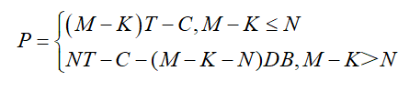（1）

The number of passengers arriving before boarding is M-K. When M-K <= N, the seats for passengers are adequate (e.g., 0 denied boarding cases). On this occasion, the profit for this flight is the total revenue minus the cost. However, when M-K>N, the number of passengers arriving before boarding is larger than the number of seats in the plane (the capacity), which means that some passengers will be denied boarding. In this case, the compensation for passengers denied boarding should be treated as an extra cost when calculating for profits.

The simulation can therefore be written as (1), where there is an upward line followed by a downward line, separated by whether the variance between the number of total tickets sold and no-shows exceeds passenger capacity.

As it is assumed that P(K) complies with binomial distribution, P(K) can be written as:

(2)

where:

NS is the probability of no-show for one passenger.

A is the probability of a passenger arriving at the airport successfully.

K is the number of no-show passengers.

M is the number of bookings before taking off.

Simple as the two functions are, they can be used for predicting by determining the cumulative distribution function of P(K) and then solving P for M accordingly. For example, given the known N and P(K), the probability of M-K>N can be calculated. One can then decide whether to use the first part or the second part of (1) accordingly. An example is shown below in Figure 1:

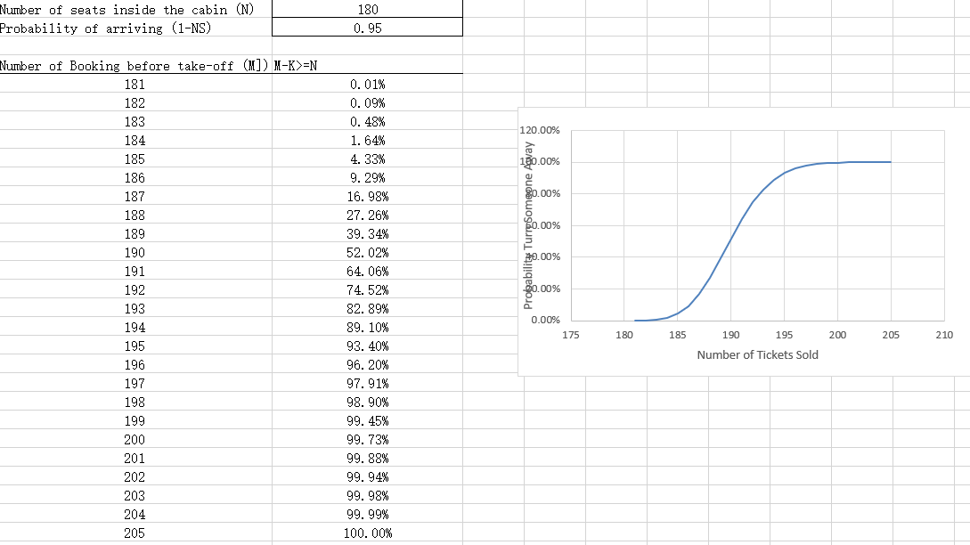

*Figure 1*

In this case, it is obvious that it is very likely that the second part of P would be applied if M exceeded a certain level (i.e., 194) with given values of capacity & no-show probability per passenger.

However, this approach is very much simplistic. Considering that the actual number of passengers coming varies on a case-by-case basis, the use of mathematical expectation to express the profit of airline is adopted to build a more accurate model:

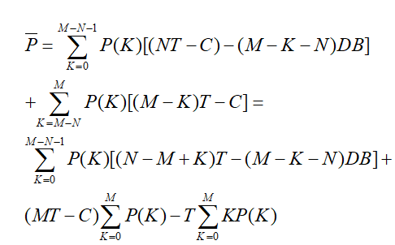(3)

Equation (3) converts (1) to an expected value form by adding up the profits in each situation according to different numbers of people coming (i.e., multiplied by P(K)s). (3) thus represents the expected profits.

# Solving the Equation

Taking a closer look towards (3), considering that 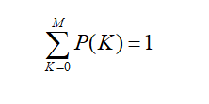, and that 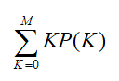 is the expected K value which can be written as , (3) can be rewritten as:

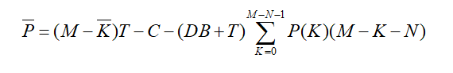(4).

According to IATA (2021), the break-even load factor for 2020 was 78%. In other words, it was only when 78% or above of the seats were filled that a specific flight was profitable. The figure is adopted so C = 0.78 NT. (4) can subsequently be rewritten as:

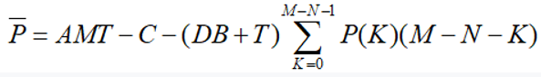(5) by replacing  with A*M, and then:

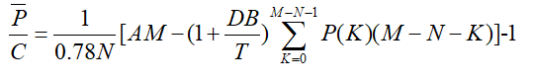（6).

In this equation, C, T, DB are parameters that remain constant in the short term; N is a non-variable parameter; K is an uncontrollable parameter that the airline company cannot manipulate; m is a parameter that the company can manipulate. Therefore, in one specific flight route, T, DB, C, K, N are known. In this situation, it can be seen that the expected profit  is dependent on M.

Visualised by Matplotlib module in Python, there is a line that represents the relationship between M and its corresponding when variables T, DB, C, K, N are fixed. A global maximum point can be observed when M reaches the maximum value of , which is also the optimal overselling level of M.

# Case Analysis

The data of flight No. CA1637 from Beijing to Shenzhen is selected for analysis as it is one of the busiest flights in China and is thus representative.

In this case, passenger capacity N=300, ticket price T=3000, and compensation for a denied board passenger DB=1000. In real-life situations, such an analysis typically requires longitudinal data and observations. However, for the sake of this assignment, NS is assumed to be 5%, which is derived from the no-show rate of top ten Chinese airports between 3% and 7% (Chinese Economy, 2017). Since NS=5%, the probability of a passenger who booked a ticket and turned out arriving at the airport A=1-NB=95%.

Taking N=300, T=1000, DB=1000 and A= 0.95 into equation (6), the optimal number of bookings before taking off, M, can be calculated, in which case the expected profits  reaches its highest point. The corresponding results are shown below in Figure 2:

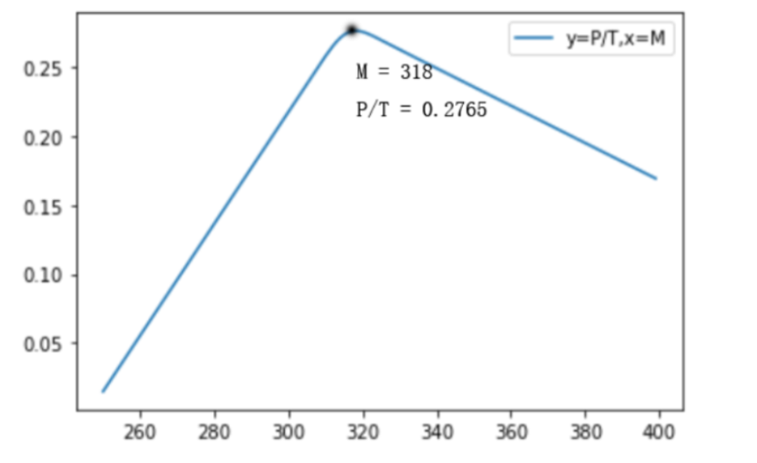

*Figure 2*

m= 318 P/T= 0.2765343680697556

As seen from figure 2, the expected return increases and then decreases as the booking number increases. At the booking level of M=318, the expected profit margin reaches its maximum at 0.2765. Therefore, the optimal booking number for this airline in this route is 318, and the company is recommended to set the overbooking level of this flight at 318.

Although it is not possible to obtain the actual booking data of this plane for comparison, the result calculated from the model still has certain values. While multi-level ticket prices are not taken into consideration, this model potentially increases the passenger load factor and reduces passenger DB (denied boarding) rates by suggesting an optimal overbooking value that maximises profits. In other words, this model provides a quantitative basis for an airline company to set its targets of overbooking.

# References

Air Transport Action Group (ATAG) (2019) Aviation Benefits Report 2019, Geneva, Switzerland: Air Transport Action Group (ATAG).

Belobaba, P. (2009) Fundamentals of pricing and revenue management. In: Belobaba, P., Odoni, A. and Barnhart, C., ed. The Global Airline Industry. s.l.:Wiley, pp. 73-112.

Chinese Economy (2017) Jipiao Chaoshou Qianguize Ziyang Minhang Liyi Zuidahua 机票超售潜规则 滋养民航利益最大化 [The Underlying Rules of Overbooking that Optimise Profits for Airline Companies]. Available at: http://finance.ce.cn/rolling/201704/24/t20170424_22253109.shtml (Accessed: 31 October 2021)

Civil Aviation Authority (2015) Denied boarding. Available at: https://www.caa.co.uk/Passengers/Resolving-travel-problems/Delays-cancellations/Denied-boarding/Denied-boarding/ (Accessed: 1 November 2021).

Dalalah, D., Ojiako, U. and Chipul, M. (2020) 'Voluntary overbooking in commercial airline reservations', Journal of Air Transport Management 86.

Ge, Y., Yin, Z. and Xu, Y. (2011) 'Overbooked with transference options for flight', Journal of Industrial and Management Optimization, 7(2), p. 449–465.

International Air Transport Association (IATA) (2017) Economic Performance of the Airline Industry. Available at: https://www.iata.org/en/iata-repository/publications/economic-reports/airline-industry-economic-performance---october-2021---report/#:~:text=We forecast the industry to, in 2022 (-2.7%25) (Accessed: 31 October 2021)

Pizam, A. (2017) 'The practice of overbooking: Lessons learned from United Airlines flight 3411', International Journal of Hospitality Management, Volume 64, pp. 94-95.

Rothstein, M. (1971) 'Airline Overbooking: The State of the Art', Journal of Transport Economics and Policy, 5(1), pp. 96-99.

Schubmehl, M., Turner, W. and Boylan, D. (2002) 'Models for Evaluating Airline Overbooking', The UMAP Journal, 23(3), p. 301–316.

Stevens, M. (2017) Chicago Airport Security Officers to Shed ‘Police’ Label After United Airlines Dragging Episode. Available at: https://www.nytimes.com/2017/07/12/us/united-chicago-airport-security.html (Accessed: 31 October 2021).

Wei, F., Su Q. and W.H. Ip. (2014) 'Research on Multi-Leg Inventory Control Based on Passenger Choice', International Journal of Engineering Business Management, 6(2).